**Title of the Paper**

### **First A. Author1*, Second B. Author², Third C. Author2,3**

1Affiliation (institution only, see example)

2 University Department of Chemistry, Magadh University, Bodh Gaya 824234, India

3Department of Aerospace Engineering, Indian Institute of Technology Madras, Chennai-600036, India

*Corresponding author: e-mail: [xxx@xxx.xxx](mailto:xxx@xxx.xxx)

#### **Keywords**: (Example) Gas turbine propulsion, Rocket propulsion, Highspeed propulsion ramjet/scramjet and other propulsion concepts, Flame speed, Rich and lean burning, Thermal analysis, Propellant parameters.

#### **Abstract:** Authors are invited to submit electronically a 4-6 page full paper on or before 15th September 2024. The full paper should contain the main concepts of the work, results and conclusions in detail.

# 1. INTRODUCTION

The paper must be written in English following the format provided below. Times New Roman font 11 pt. must be used, with the exceptions of the title (12 pt.), affiliations and references (9 pt.). The text width is 150 mm and

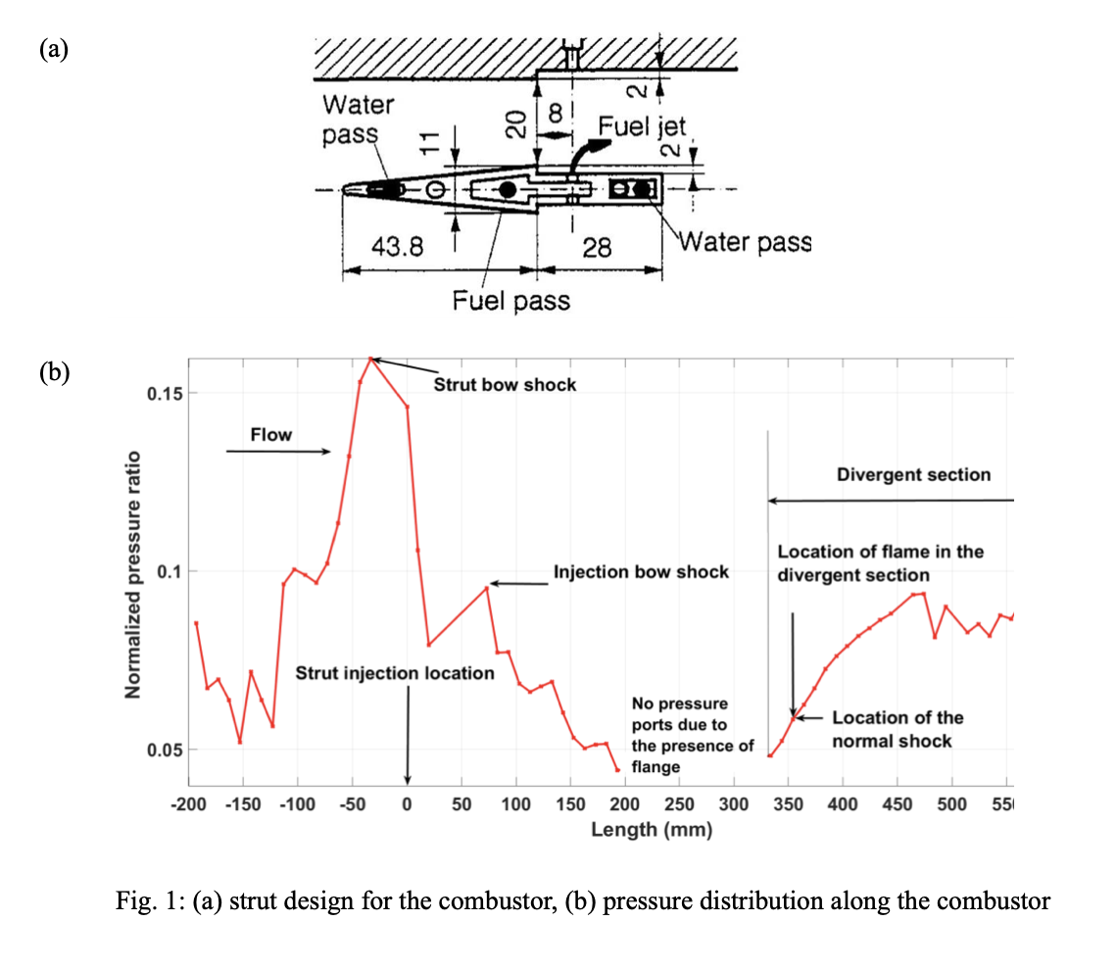

Fig 1. (a) Strut design for the combustor, (b) Pressure distribution along the combustor

should be of 4-6 pages including all text. The file must be delivered as doc/docx/pdf formats, other

formats are not accepted. Figure/picture [Fig. 1] or table [Table 1] if any, should be centered and located inside paper margins. Text should not wrap around figures or tables. Table captions (11-point font) should be centered above tables, and figure captions (11-point font) should be centered below figures. The texts in the figures must be clear and of sufficient font size for easy reading.

Brieﬂy discuss in this section the rationale for the work carried out with proper reference, the motivation, and objectives.

# 2. METHODOLOGY USED - EXPERIMENTAL / NUMERICAL / ANALYTICAL

Discuss in this section the methodology adopted for carrying out the work done.

(Picture Example)

# 3. RESULTS AND DISCUSSION

Discuss the outcome of the work with relevant plots, ﬁgures and discussions. Ensure the fonts in the plots are clear enough to read. Ensure that the axes in the plots are correctly labelled. Ensure all the figures are appropriately captioned. Ensure that the markings in figures, if any, are clearly visible to the reader. The ﬁgures and plots caption is in Times New Roman 11pt, justiﬁed, and single-spaced.

# 4. CONCLUSIONS

# Concluding remarks of the work presented in the paper.

# ACKNOWLEDGEMENTS

Details of the funding agency/grant, if any, must be in Times New Roman font 11pt size.

# REFERENCES

1. A. B. Author, C. D. Author, Journal Title 1, 37–42 (2013).
2. A. B. Author, C. D. Author, E. F. Author, Book Title (Publisher, City, 2012), 135–142.
3. A. B. Author, Proc. of the ... Conference... (Publisher, City, 2014), 45–52.
4. A. B. Author, Thesis Title (Ph.D. thesis, A University, 1998).